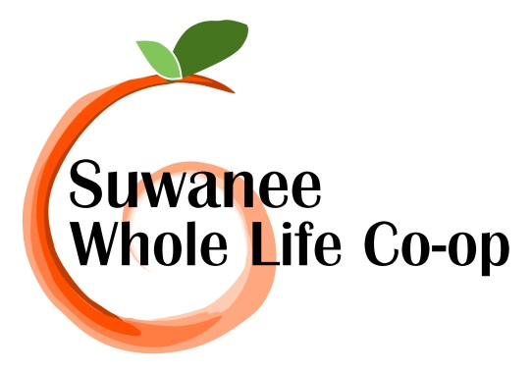
Community Resource Directory

Updated 6/27/13
REAL fOOD. rEAL FARMERS. REAL COMMUNITY
A directory of our co-op member local businesses, products and services

The Purpose and Benefit of this Directory
The purpose of this directory is to help co-op members advertise their products or services and to foster a sense of community.
If you are an active member and would like to list your service or business, please send me an email with your name, business name, brief description, website address and contact information. The directory will be updated on a monthly basis.
I’m looking forward to supporting all our local business owners and I hope you are too!
Products and Services:
Automobile sales

DSI Autosales
Mike Combee
Manager
3630 Burnette Park Dr. B
Suwanee, GA 30024
770-271-9306
www.dsiautosales.com

Handmade Accessories
Sariyana's Bowtique
Description: Beautiful Girly Accessories (headbands, clips, etc.) for babies to adults
Alana Stander
Website: www.SariyanasBowtique.etsy.com
Facebook: www.facebook.com/SariyanasBowtique
Email: SariyanasBowtique@gmail.com
Health Resources

ADHD Autism Resources
Tutoring and Educational Interventions
Jennifer Scoville
770-710-7340

Pet grooming, boarding, daycare and holistic pet foods

The PawPlex
3580 Lawrenceville- Suwanee Rd.
Tracy Duncan
678-765-0981
www.thepawplex.com

residential remodeling contractor

Hamilton Design-Build, LLC.
3rd Generation Craftsman

Remodeling, repairs, home maintenance and handyman services

John Hamilton Morse IV
770-241-7150
www.hamiltondb.com

Wine Consultation & Sales

WineShop At Home
Joanna Ortega

I am an independent wine consultant for WineShop At Home, a Napa Valley winery. We specialize in private, in-home wine tastings of our exclusive artisan wines. We also offer wine club memberships, custom wine labels for personal or corporate gifts, weddings or birthdays and wine gift baskets for any occasion. Interested in hosting a wine tasting or giving classy wine gifts? I can be reached at 404-409-7117 or via email at oncloudwine@gmail.com.

Website: http://www.wineshopathome.com/joannaortega
Facebook: https://www.facebook.com/#!/joannaoncloudwine

